Student Name : Pyae Phyo Aung
Student ID : 0526017003
Class/Batch : Professional Diploma in AI (Batch-1)
Assignment Name : IV

- Flask application successfully tested locally
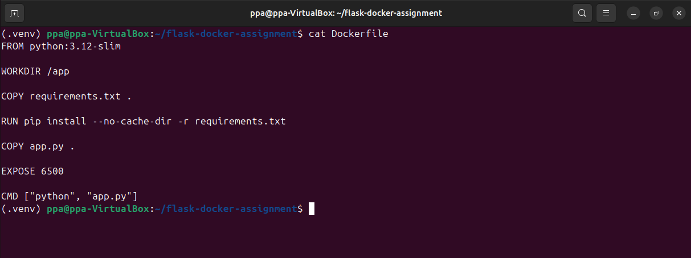
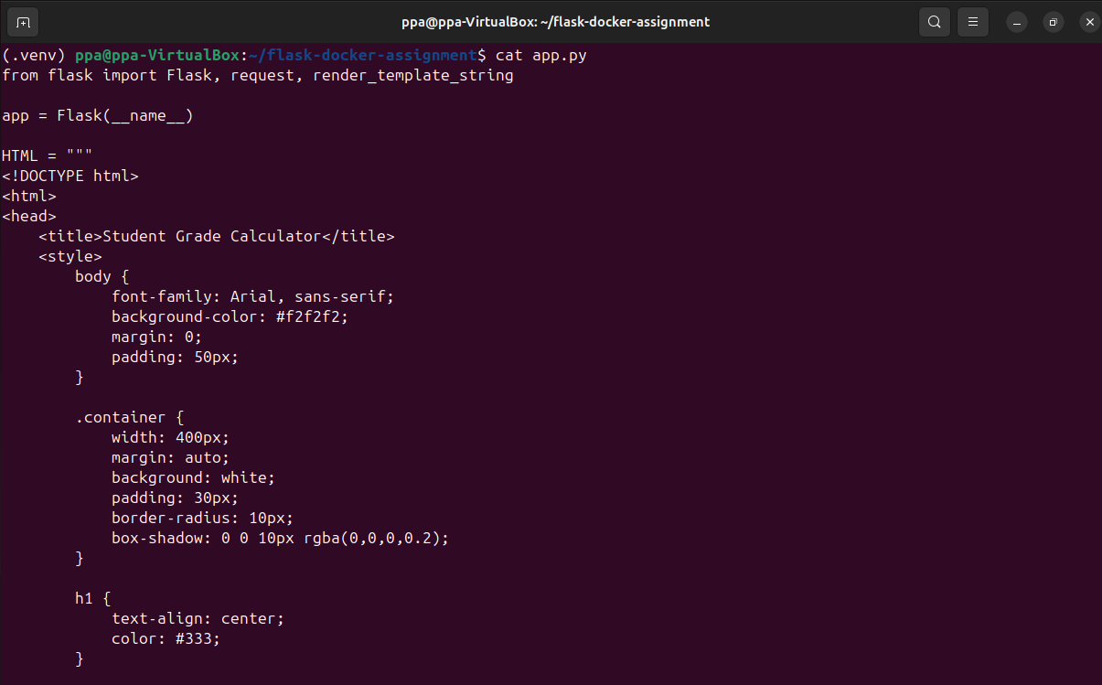

- Flask application successfully tested locally

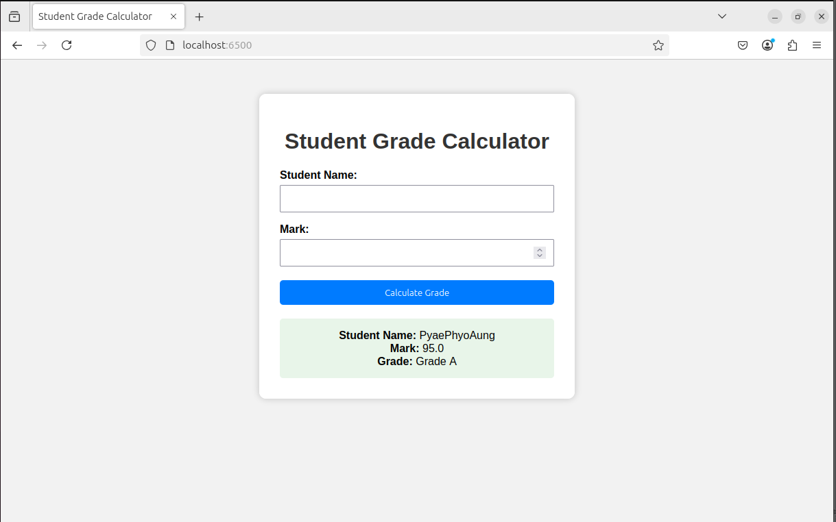

- Docker image grade-app:v1 successfully built
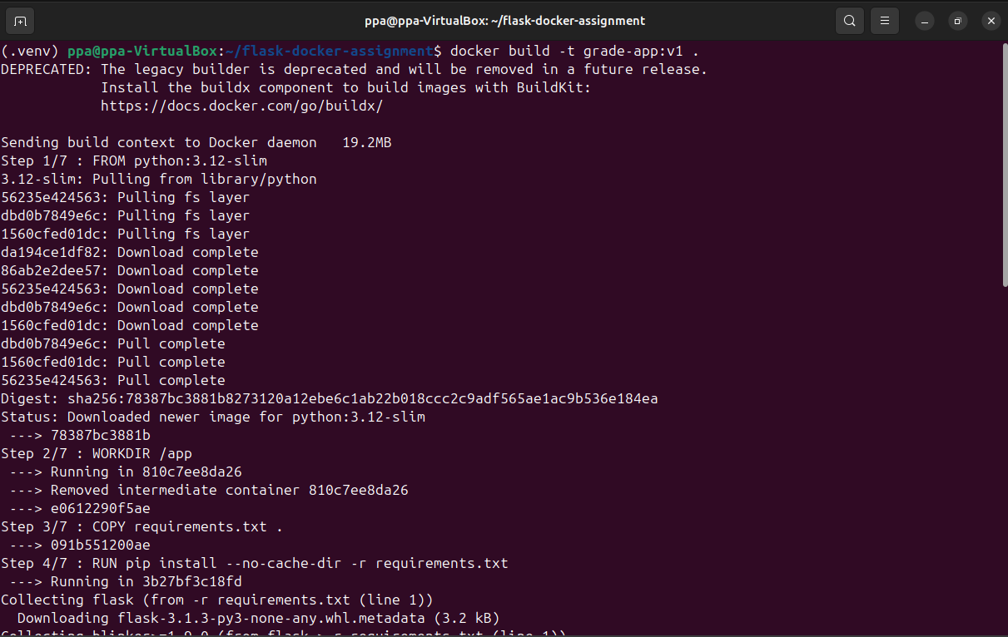
- docker images showing grade-app:v1
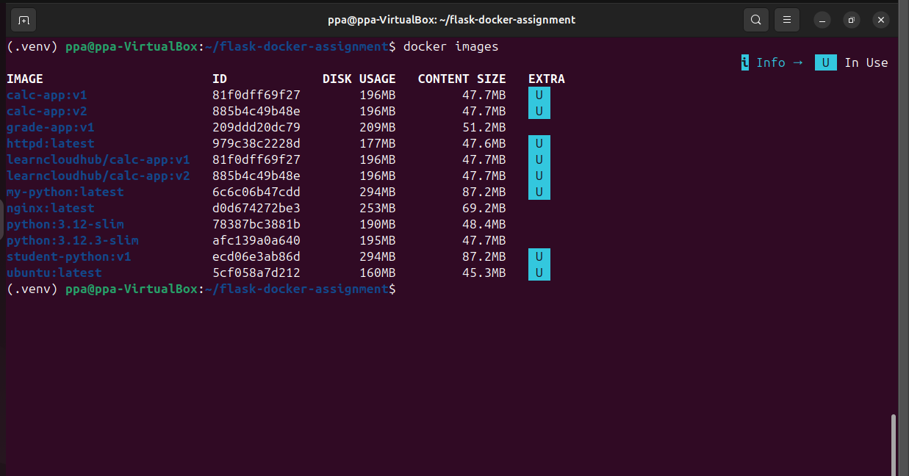

- Container grade1 successfully created and running
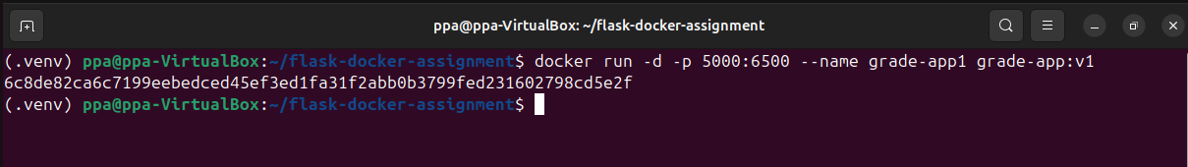

- docker ps showing the 5000 → 6500 port mapping
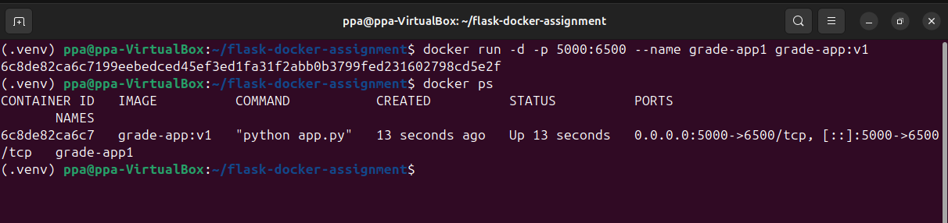

- Browser showing a successful grade result
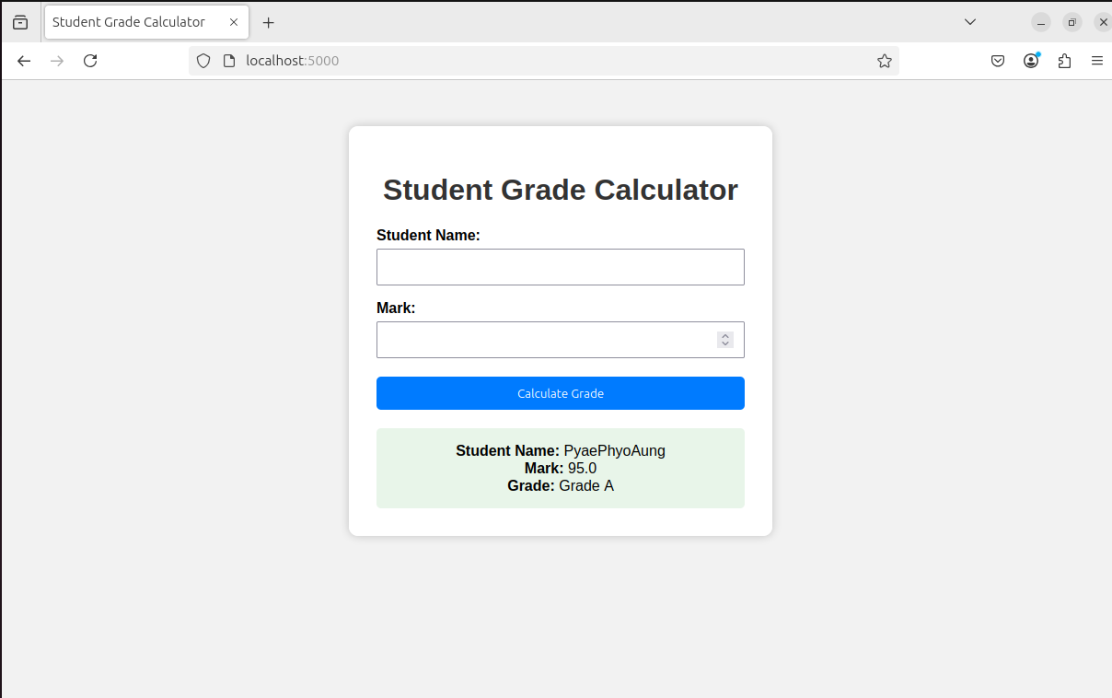

- Browser showing the Invalid Mark test result
